Assignment8.1

Creating the table emp





Displaying the table emp

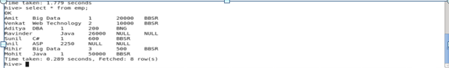

Creating the view max_sal from table emp



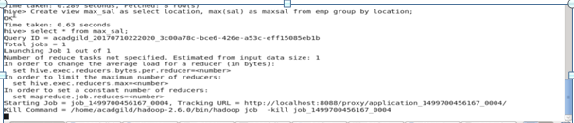

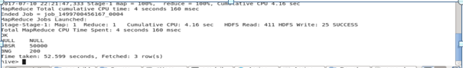

Task 2:



